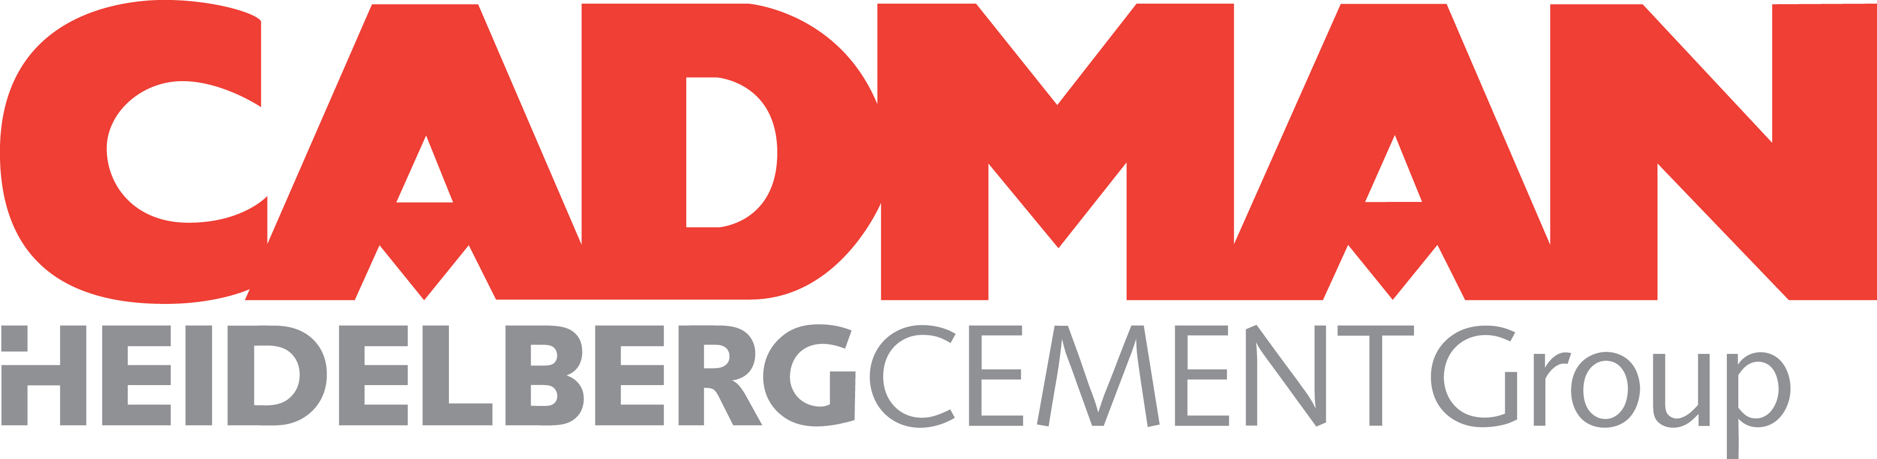

Petroleum Contaminated Soil Site Information Sheet
Applicant
Company Name:
Contact: |  | Phone:
Title:

Project to be Billed/ Ticketed To:
Company Name:
Company Address:
P. O Number, Job Name/Number,
Property Owner:
Owners Address:

Site Information
Site Address:
Current & Previous Use of Property (check all that apply):
Fueling Stat |  | Inorganic Chemicals |  | Plastic & Rubber |  | Paints or Solvents
Agriculture Chemicals |  | Residential |  | Primary Metals |  | Metal Plating
Metal Forging, Stamping |  | Electronic Equipment |  | Lumber & Wood Products |  | Retail
Recycling |  | Junk/ Salvage Yard |  | Wrecking Yard |  | Landfill
Oil & Gas Mining |  | Metals Mining |  | Mining non-metallic matl’s. |  | Other Manufacturing
Source of Contamination:
Estimated Amount: | Tons Drums |  |  |  | Actual

SOIL DATA
Attach test results showing:
Total RCRA metals | WTPH -D (WTPH-D EXTENDED)
Moisture Content | BTEX
Percent Physical Contamination | WTPH-G
Sampling Plan & Procedures | Other tests as required  *PCB Analysis required for Heavy / Mineral Oil Contamination*

CERTIFICATION
The above information is true and correct to the best of my knowledge, and is representative of the actual material to be delivered to Cadman:
Signed: |  | Date:
 | Authorized Representative

